EMAIL TEMPLATE 1: MATCHED GIVING

SUBJECT LINE: Can you help us get <Organisation’s name> on the fundraising leaderboards?

Hi <Name>,

I’m riding in the 2026 MACA Cancer 200 Ride for the Perkins. Over two days, my team and I, <team name>, will ride 200km to raise life-changing funds for cancer research right here in WA.

As part of our efforts, we hope to raise at least $<TOTAL> for the Harry Perkins Institute of Medical Research. I would love to ask <organisation’s name> to match the funds we raise!
Like many riders, I’ve/we’ve been impacted by cancer. I’m riding this year in honour of…. (If you’re riding for someone, please share your story here. No matter your reasons, let your employer know why you’ve decided to ride!)

Last year, 2000 riders raised $10M for cancer research. It attracts some of WA’s biggest workplaces and continues to grow in popularity, year after year.

Workplace dollar matching will have a big impact for cancer research, boost team morale and most importantly, and improve health outcomes for more West Australians.

To explain more, I’ve included a brief, informative video from the CEO of the Perkins, Professor Peter Leedman below.

Matched Giving

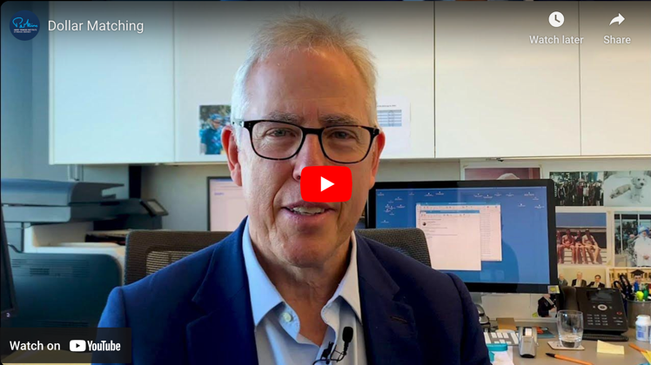
To participate, all team members must raise a minimum of $2500 for cancer research. But we hope to raise as much as possible! For every $1 we raise, we’d like to invite <organisation’s name> to match it.

Together, we can help the Perkins develop kinder, more effective treatments so our loved ones can live long and healthy lives.

There are benefits to <organisation’s name> too! Some of these include:

- Improved employee engagement. By supporting what’s important to your employees, you’ll foster a sense of pride and connection
- Aligned values. We’re proud to represent <organisation> on the Ride and demonstrate our company values
- Team building. Nothing fosters teamwork like a 200km challenge to Mandurah and back. It’s a unique opportunity to foster collaboration.
- Improved giving. Data shows matched giving can encourage our team to raise even more. It could help us smash our goals and top the fundraising leaderboards.

I’d love to chat more about how <organization’s name> can show their support for our team and cancer research in WA. If I can provide more info, please reply to this email. Otherwise, I’ll follow up in a few days!

Thank you for your consideration. I hope to hear from you soon.

<Your Name>

EMAIL TEMPLATE 1: FOLLOW UP MATCHED GIVING

SUBJECT: Is Matched Giving possible?

Hi <Name>,

I’m following up on my earlier email about matched giving.

The MACA Cancer 200 Ride for the Perkins will be held on 17 & 18 October 2026. We’d be incredibly grateful if <organisation> can offer matched funding for our efforts.

With your help, we hope to challenge some of the other workplace teams on the fundraising leaderboards. It will raise the profile of <organisation’s> impact for cancer research!

Most importantly, matched giving will have a significant impact on health outcomes in Western Australians.
This year, there will be almost 14,000 West Australians who will face a devastating cancer diagnosis.

A contribution from <organisation> can provide vital equipment, lab essentials and attract some of the best scientific minds to the Perkins.

The Perkins are committed to tackling some of the hardest, toughest cancers. We are too! If I can provide more information, or chat to someone about making a donation, I’d appreciate it.

You can also reach out directly to the Perkins Ride team.

Thank you again!

<Your Name>

